- Purpose

The purpose of this procedure is to establish a maintenance program for the Titrette Bottle-Top Burette used for USP analysis. This procedure will help to insure compliance with 21 CFR 211.67 ‘Equipment Cleaning and Maintenance’.

- Scope

This procedure applies to the USP bottle-top burette (S/N: 08L62300). Maintenance will be performed on the bottle-top burette by QA Lab personnel every 8 weeks or any time a drop in performance is noted.

- Responsibility

QA Lab personnel are responsible for performing this procedure.

- Safety Considerations

Appropriate PPE should be worn at all times including but not limited to steel-toed shoes, gloves (nitrile or latex), safety glasses, and a lab coat.

Safety is a condition of employment. Employees are not authorized to work in an unsafe manner and are prohibited from harming the environment of the facility or community.

- Materials/Equipment

  - Brand Titrette® bottle-top burette
  - Bottle (at least 500 ml) filled with deionized water
  - Receiving vessel (e.g., Erlenmeyer flask) with bottom of vessel covered with deionized water
  - Nitrile gloves
  - Laboratory tissue wipers

- Procedure

The instrument must be cleaned every 8 weeks or if any of the following should occur:

- Must be cleaned immediately if the hand wheels become harder than usually to turn.
- Before changing any reagent.
- Prior to dismantling the instrument or long term storage.
- If liquid has accumulated in the screw cap of the titration tube.
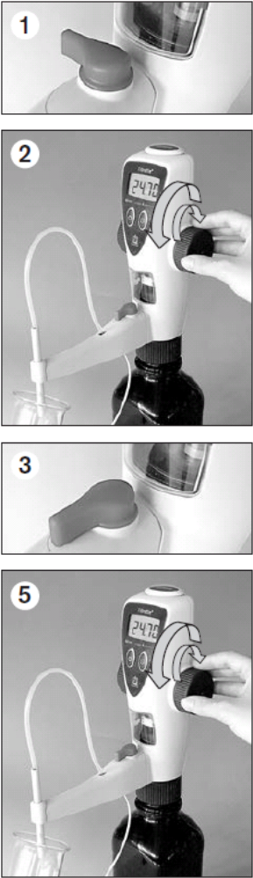
Standard Cleaning

- Set the valve to 'Recirculation' (Fig. 1), and empty the instrument completely by turning the hand wheels.

- Screw the instrument onto a bottle filled with deionized water and rinse the instrument several times by completely filling and emptying it (Fig. 2).

- Set the valve to 'Titrate' and unscrew the closure cap from the titration tube then place a suitable receiving vessel under the titrating tube. Rinse the instrument several times by completely filling and emptying it (Fig. 3).

- If deposits appear in the dispensing cylinder, this process can be repeated with a suitable cleaning agent followed by another thorough with deionized water.

- Screw the instrument onto an empty bottle and empty the piston completely by turning the fill/dispense knob back and forth in both the "Recirculation" and in the "Titration" valve setting (Fig. 5).

- Unscrew the air vent cap by hand or use a coin.

- Remove the rear housing and take out the mounting tool.

- Loosen the safety ring of the piston/cylinder assembly with the mounting tool, and unscrew it completely by hand (Fig. 9).

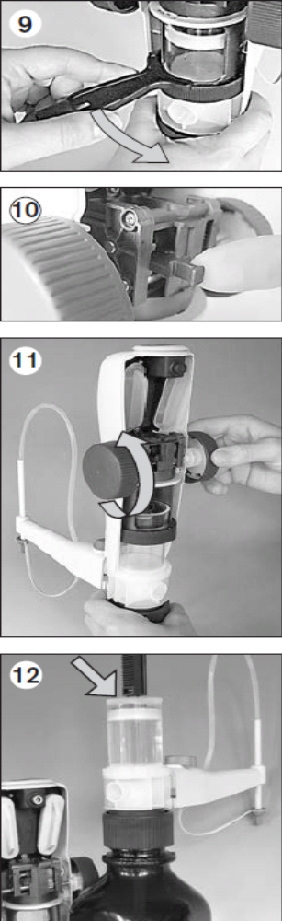
- Withdraw the locking mechanism of the piston rod up to the stop (Fig. 10).

- Move the top part of the instrument all the way to the top by turning the hand wheels, and remove it (Fig. 11).

- Remove possible crystal deposits at the upper edge of the dispensing cylinder with water and a soft bottle-brush. Then, dry it off with a lint free wipe (Fig. 12).

- Remount the top of the instrument, or further dismantle the instrument for intensive cleaning if necessary.

- Document Cleaning on Maintenance Log (L15-FM-100-019)

Notes: Depending on frequency of use, it is recommended that any crystalline deposits on top of the piston be removed on regular intervals of approx 8 weeks. For this, carry out steps 6-13.

7.0 Reference Documents:

Maintenance Log (L15-FM-100-019)

8.0 Change Information:

New Document

